Lab 12. Javascript & AJAX
Prepared: TrangNTT
Lab 12. Javascript & AJAX 1
12.1. Some simple JS examples 2
12.2. Validate for login form 5
12.3. Exercise 1 - Event Handling (JS) 7
12.4. PHP and AJAX example 7
12.5. AJAX & MySQL example 12
12.6. Exercise 2– Inheritance (JS) 14
12.7. Exercise 3 – Validate inputs (JS) 14
12.8. Exercise 4 – Search suggestions by AJAX 14

Note: Using Firebug to debug Javascript.

Some simple JS examples

Array
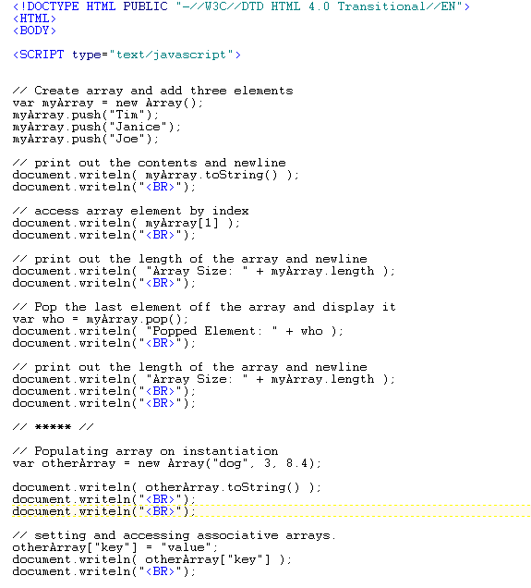
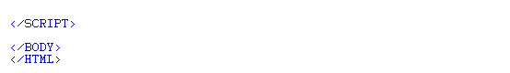
Result:
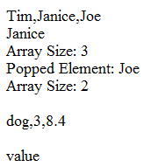

Open new window
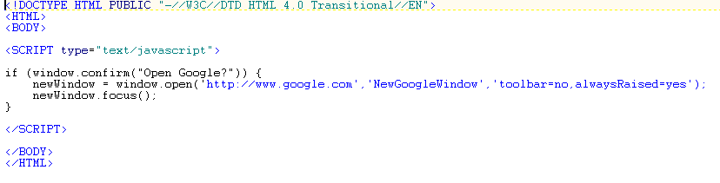

Count the Function calls
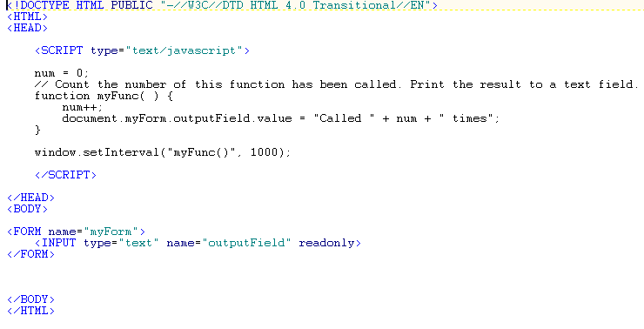

Set controls’ attributes
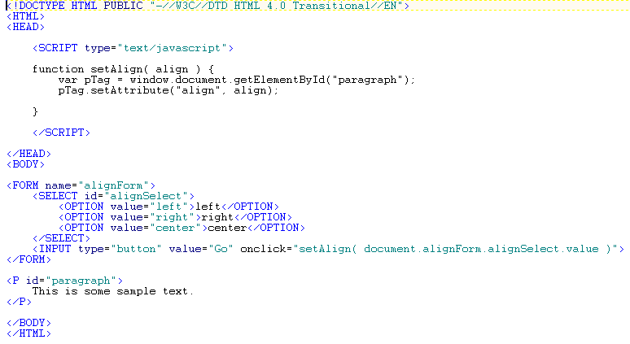

Add text fields
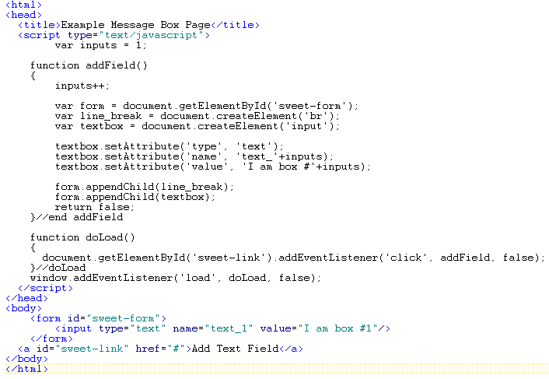

Validate postal code and money using RE (JS)
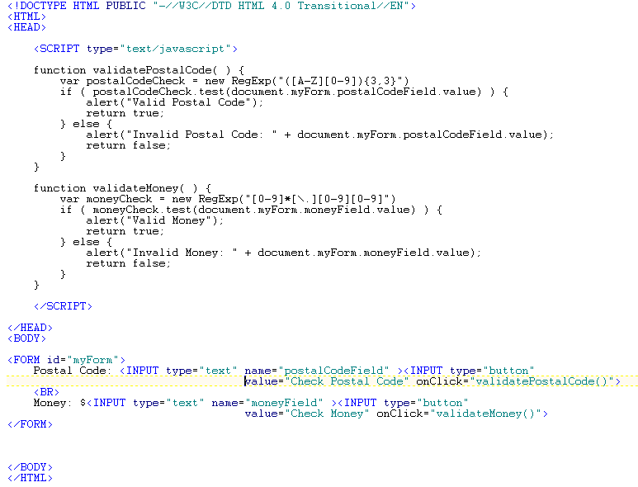

Validate for login form

Create login form
- Download the style.css in Lab folder in course website to get the style for login.php.
- Get the login form in the exercise 9.4 of Lab 09 and modify as the following:
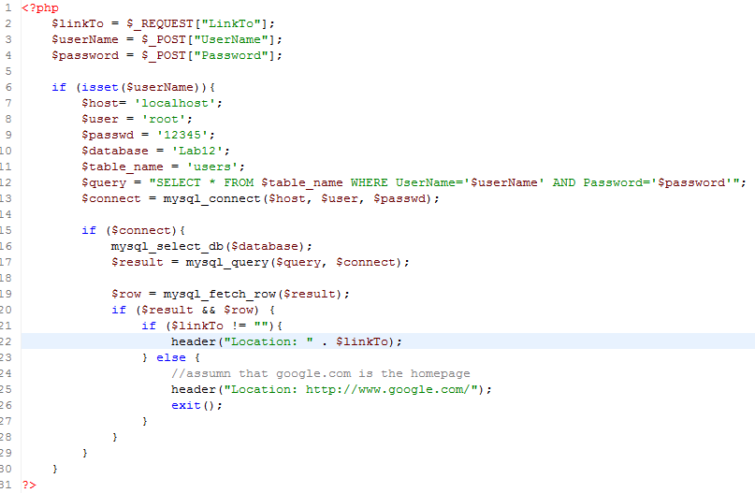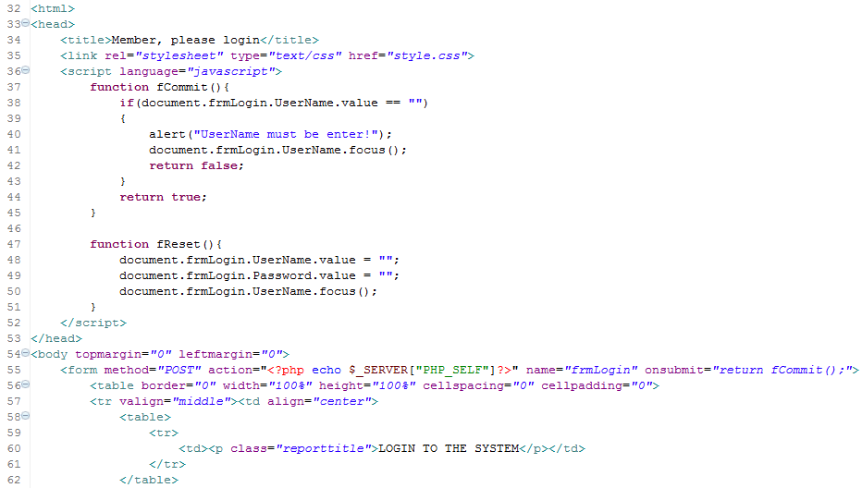

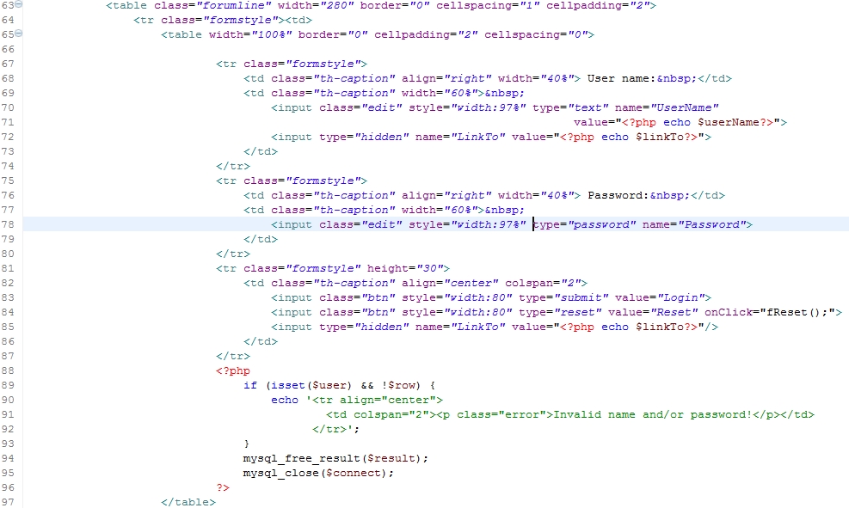
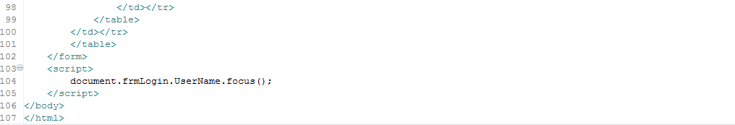

Run some special cases to check if the validation is good or not.

Exercise 1 - Event Handling (JS)
Write a simple HTML document called colors.html containing three colored links at the top of the page labeled RED, GREEN, and BLUE. Under the links there should be a small paragraph of text (you make this up) with a starting color of BLACK. Using onMouseOver and onMouseOut events of the links, when a user rolls over the each and any of the color labeled links, the color of the text in the paragraph below should change to the color corresponding to the link the user is hovering over. When the user rolls off the link, the color of the text should go back to it's starting color of BLACK.

PHP and AJAX example

Ajax basics
This example only focus on how to create a basic working AJAX - PHP communication. The only important thing at the moment is that AJAX uses JavaScript so it need to be enabled in your browser to successfully complete this example.
To demonstrate the AJAX PHP connection we will create a very simple form with 2 input fields. In the first field you can type any text and we will send this text to our PHP script which will convert it to uppercase and sends it back to us. At the end we will put the result into the second input field (The example maybe not very useful but I think it is acceptable at this level).
So let's list what we need to do:
- Listen on key-press event on the input field.
- In case of key-press send a message to the PHP script on the server.
- Process the input with PHP and send back the result.
- Capture the returning data and display it.
Our html code is very simple it looks like this:
- <!DOCTYPE html PUBLIC "-//W3C//DTD XHTML 1.0 Transitional//EN"
- "http://www.w3.org/TR/xhtml1/DTD/xhtml1-transitional.dtd">
- <html xmlns="http://www.w3.org/1999/xhtml">
- <head>
- <meta http-equiv="Content-Type" content="text/html; charset=utf-8" />
- <title>Ajax - PHP example</title>
- </head>

- <body>

- <form name="testForm">
- Input text: <input type="text" onkeyup="doWork();" name="inputText" id="inputText" />
- Output text: <input type="text" name="outputText" id="outputText" />
- </form>
- </body>
- </html>
As you can see there is a doWork() function which is called in every case when a key is up (a key was pressed). Of course you can use any other supported events if you want.
But what is this doWork() and how we can send messages to the server script? On the next page you will find the answers.

Sending data to PHP with Ajax
Before the explanation of the doWork() function we first need to learn a more important thing. To make a communication between the client and the server the client code needs to create a so called XMLHttpRequest object. This object will be responsible for AJAX PHP communication.
However creating this object is bit triky as the browser implement it various ways. If you don't want to support the quite old browsers we can do it as follows:
- // Get the HTTP Object
- function getHTTPObject(){
- if (window.ActiveXObject)
- return new ActiveXObject("Microsoft.XMLHTTP");
- else if (window.XMLHttpRequest)
- return new XMLHttpRequest();
- else {
- alert("Your browser does not support AJAX.");
- return null;
- }
- }
Ok, now we have the XMLHttpRequest object, so it's time to implement the business logic inside the doWork() function.
First of all we need to get a valid XMLHttpRequest object. If we have it then we can send the value of the inputText field to the server script. We do this by composing an URL with parameter, so in the PHP script we can use the $_GET super-global array to catch the data. As next step we call the send() function of the XMLHttpRequest object which will send our request to the server. At the moment our doWork() function looks like this:
- // Implement business logic
- function doWork(){
- httpObject = getHTTPObject();
- if (httpObject != null) {
- httpObject.open("GET", "upperCase.php?inputText="
- +document.getElementById('inputText').value, true);
- httpObject.send(null);

- }
- }
It's nice but how we can catch the response from the server? To do this we need to use an other special property of the XMLHttpRequest object. We can assign a function to this parameter and this function will be called if the state of the object was changed. The final code is the following:
- // Implement business logic
- function doWork(){
- httpObject = getHTTPObject();
- if (httpObject != null) {
- httpObject.open("GET", "upperCase.php?inputText="
- +document.getElementById('inputText').value, true);
- httpObject.send(null);
- httpObject.onreadystatechange = setOutput;
- }
- }
The last step on client side is to implement the setOutput() function which will change the value of our second field. The only interesting thing in this function that we need to check the actual state of the XMLHttpRequest object. We need to change the field value only if the state is complete. The readyState property can have the following values:
- 0 = uninitialized
- 1 = loading
- 2 = loaded
- 3 = interactive
- 4 = complete
So the setOutput() looks like this:
- // Change the value of the outputText field
- function setOutput(){
- if(httpObject.readyState == 4){
- document.getElementById('outputText').value
- = httpObject.responseText;
- }

- }
Now the client side is ready let's implement the server side.

PHP code and the complete AJAX example
Implementing the server side functionality is very simple compared to the client side. In the PHP code we just need to check the $_GET super-global array. Afterwards convert it to uppercase and echo the result. So the PHP code is this:
- <?php
- if (isset($_GET['inputText']))
- echo strtoupper($_GET['inputText']);
- ?>
That's really short, isn't it?
At least you can find the complete client and server code below.
Client:
- <!DOCTYPE html PUBLIC "-//W3C//DTD XHTML 1.0 Transitional//EN"
- "http://www.w3.org/TR/xhtml1/DTD/xhtml1-transitional.dtd">
- <html xmlns="http://www.w3.org/1999/xhtml">
- <head>
- <meta http-equiv="Content-Type" content="text/html; charset=utf-8" />
- <title>Ajax - PHP example</title>
- </head>

- <body>

- <script language="javascript" type="text/javascript">
- <!--
- // Get the HTTP Object
- function getHTTPObject(){
- if (window.ActiveXObject) return new ActiveXObject("Microsoft.XMLHTTP");
- else if (window.XMLHttpRequest) return new XMLHttpRequest();
- else {
- alert("Your browser does not support AJAX.");
- return null;
- }
- }

- // Change the value of the outputText field
- function setOutput(){
- if(httpObject.readyState == 4){
- document.getElementById('outputText').value = httpObject.responseText;
- }

- }

- // Implement business logic
- function doWork(){
- httpObject = getHTTPObject();
- if (httpObject != null) {
- httpObject.open("GET", "upperCase.php?inputText="
- +document.getElementById('inputText').value, true);
- httpObject.send(null);
- httpObject.onreadystatechange = setOutput;
- }
- }

- var httpObject = null;

- //-->
- </script>

- <form name="testForm">
- Input text: <input type="text" onkeyup="doWork();" name="inputText" id="inputText" />
- Output text: <input type="text" name="outputText" id="outputText" />
- </form>
- </body>
- </html>
Server:
- <?php
- if (isset($_GET['inputText']))
- echo strtoupper($_GET['inputText']);
- ?>

AJAX & MySQL example

AJAX Database Example
The following example will demonstrate how a web page can fetch information from a database with AJAX:
Example


Firstname | Lastname | Age | Hometown | Job
Peter | Griffin | 41 | Quahog | Brewery

Create the User table in MySQL Database
The database table we use in the example above looks like this:
id | FirstName | LastName | Age | Hometown | Job
1 | Peter | Griffin | 41 | Quahog | Brewery
2 | Lois | Griffin | 40 | Newport | Piano Teacher
3 | Joseph | Swanson | 39 | Quahog | Police Officer
4 | Glenn | Quagmire | 41 | Quahog | Pilot

Create the HTML Page
When a user selects a user in the dropdown list above, a function called "showUser()" is executed. The function is triggered by the "onChange" event:
<html>
<head>
<script type="text/javascript">
function showUser(str){
if (str=="") {
document.getElementById("txtHint").innerHTML="";
return;
}
if (window.XMLHttpRequest){
// code for IE7+, Firefox, Chrome, Opera, Safari
xmlhttp=new XMLHttpRequest();
}
else {
// code for IE6, IE5
xmlhttp=new ActiveXObject("Microsoft.XMLHTTP");
}
xmlhttp.onreadystatechange=function() {
if (xmlhttp.readyState==4 && xmlhttp.status==200){
document.getElementById("txtHint").innerHTML=xmlhttp.responseText;
}
}
xmlhttp.open("GET","getuser.php?q="+str,true);
xmlhttp.send();
}
</script>
</head>
<body>
<form>
<select name="users" onchange="showUser(this.value)">
<option value="">Select a person:</option>
<option value="1">Peter Griffin</option>
<option value="2">Lois Griffin</option>
<option value="3">Glenn Quagmire</option>
<option value="4">Joseph Swanson</option>
</select>
</form>
<br />
<div id="txtHint"><b>Person info will be listed here.</b></div>
</body>
</html>
The showUser() function does the following:
- Check if a person is selected
- Create an XMLHttpRequest object
- Create the function to be executed when the server response is ready
- Send the request off to a file on the server
- Notice that a parameter (q) is added to the URL (with the content of the dropdown list)

Create the PHP File
The page on the server called by the JavaScript above is a PHP file called "getuser.php".
The source code in "getuser.php" runs a query against a MySQL database, and returns the result in an HTML table:
<?php
$q=$_GET["q"];
$con = mysql_connect('localhost', 'peter', 'abc123');
if (!$con) {
die('Could not connect: ' . mysql_error());
}
mysql_select_db("ajax_demo", $con);
$sql="SELECT * FROM user WHERE id = '".$q."'";
$result = mysql_query($sql);
echo "<table border='1'>
<tr>
<th>Firstname</th>
<th>Lastname</th>
<th>Age</th>
<th>Hometown</th>
<th>Job</th>
</tr>";
while($row = mysql_fetch_array($result)) {
echo "<tr>";
echo "<td>" . $row['FirstName'] . "</td>";
echo "<td>" . $row['LastName'] . "</td>";
echo "<td>" . $row['Age'] . "</td>";
echo "<td>" . $row['Hometown'] . "</td>";
echo "<td>" . $row['Job'] . "</td>";
echo "</tr>";
}
echo "</table>";
mysql_close($con);
?>

Explanation: When the query is sent from the JavaScript to the PHP file, the following happens:
- PHP opens a connection to a MySQL server
- The correct person is found
- An HTML table is created, filled with data, and sent back to the "txtHint" placeholder

Exercise 2– Inheritance (JS)
Implement and try to understand the following source code
var Person = function() {};

Person.prototype.initialize = function(name, age)
{
this.name = name;
this.age = age;
}

Person.prototype.describe = function()
{
return this.name + ", " + this.age + " years old.";
}

var Student = function() {};
Student.prototype = new Person();

Student.prototype.learn = function(subject)
{
console.log(this.name + " just learned " + subject);
}

var me = new Student();

me.initialize("John", 25);
me.learn("Inheritance");

Next, create an object called Teacher derived from the Person class, and implement a method called teach which receives a string called subject, and prints out:

[teacher's name] is now teaching [subject]

Exercise 3 – Validate inputs (JS)
Create a register form and validate inputs in the form (username… not null, email, telephone in the right format…)

Exercise 4 – Search suggestions by AJAX
Develop a PHP application which allows users to search product information of your company. Everytime users enter any character in the product name, provide suggestions corresponding with entered characters. Using AJAX to complete the exercise.

